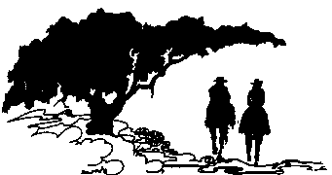
````````` Greater Randolph Area Trail Riders
P.O. Box 293, Schertz, Texas 78154
Membership Application
(Or to Update Current Membership Information)
GRA-TRAils dues for year ______ are $20.00 per Family (one family earns one Vote unless both spouses become members). Anyone wishing to serve on the board must be a paid GRA-TRAils Member (membership application must be in their own name). Please return application and dues to address above or give to any board member.
Name: ______________________________________ Occupation: _________________________________________
Spouse: ______________________________________ Occupation: _________________________________________
Child (1) : ____________________________________ Child (2) : _________________________________________
Child (3) : ____________________________________ Child (4) : _________________________________________
Address: __________________________________________________________________________________________
__________________________________________________________________________________________________
Email Address (s): __________________________________________________________________________________
Home Phone: ______________________________ Cell Phone: _________________________________________
I do (___) or do not (___) Authorization GRA TRAils to publish the following (please initial below):
____ Address & phone numbers for website/directory ____ Facebook photographs ____ Website Photographs
Volunteers: ____ Parties ____ Trail Rides _____ Scholarship Committees
Paid: ___ Cash ___ Check
I hereby apply for active membership in the Greater Randolph Area Trail Riders Association (GRA-TRAils). I will comply with the constitution and By-Laws of this organization. I will regularly attend meetings and will participate in GRA-TRAils projects & rides when available.
Signature of Applicant _______________________________________________________ Date _________________
Signature of GRA-TRAils Member ____________________________________________ Date _________________

Date Submitted to Board of Directors __________________________ Date Approved ____________________________
Yearly Events **January Warm Ride** February Week Long **April Easter Ride ** May “Texas Natural” Trailride San Marcos, Texas
** June/July TBA Queen’s Ride ** July TBA Schertz Parade
** Oct TBA Scholarship Ride ** Nov TBA Veteran’s Ride ** Dec TBA Christmas Party **
!! Drinks provided on rides only and majority of our rides include meals !!

